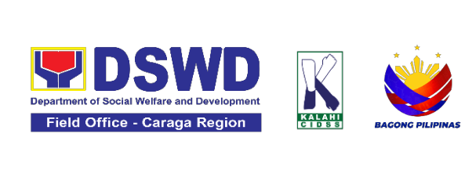

DRN: CARAGA-FO-DRMD-DRRMS-A-COMM-25-09-30918-S
GOOD PRACTICE DOCUMENTATION
- Title | KliMalasakit Online Document Updating System (KODUS)  Risk Resiliency Program through Cash for Training and Work (RRP-CFTW) for Local Adaptation to Water Access and Breaking Insufficiency through Nutritious Harvest for the Impoverished (LAWA at BINHI)  Proponent Office: Disaster Response Management Division – Risk Resiliency Program
- Context | The Department of Social Welfare and Development (DSWD) Field Office Caraga developed the Klimalasakit Online Document Updating System (KODUS) to improve operational efficiency and strengthen data integrity in the implementation of the Risk Resiliency Program – Cash for Training and Work (RRP-CFTW), particularly under Project LAWA and BINHI.  Before the system was developed, field operations depended on manual spreadsheets and fragmented processes to track documents, validate masterlists, and generate sectoral reports. These traditional methods were labor-intensive, error-prone, and inconsistent, especially when handling large volumes of beneficiary data across multiple municipalities.  KODUS was designed to address these operational challenges by automating workflows, reducing duplication, and providing real-time visibility into program implementation. The system is web-based and is accessible only to authorized personnel, ensuring compliance with data privacy protocols while fulfilling program-specific requirements.  Its primary functionalities include:  - Tracking document flow across program phases  - Managing the Masterlist of Eligible Partner-Beneficiaries  - Generating disaggregated data reports by sex, age, sector, and category  - Performing record deduplication and cross-matching  Since its deployment, KODUS has significantly improved turnaround time, enhanced data accuracy, and strengthened reporting consistency. It has become an indispensable tool for program implementers, technical staff, and decision-makers, while also serving as a replicable model of internal digital innovation that may be adopted across other DSWD programs and Field Offices.
- Implementation | - Pre-Implementation Phase  Before the development of KODUS, the implementation of the Risk Resiliency Program – Cash for Training and Work (RRP-CFTW) under Projects LAWA and BINHI faced persistent challenges in managing program documentation and partner beneficiary data. Field staff relied on manual spreadsheets and fragmented systems to track incoming and outgoing documents, validate masterlists, and generate sectoral reports. These processes were time-consuming, error-prone, and lacked standardization, especially when coordinating across multiple municipalities and program phases.  The need for a secure, centralized, and automated system became evident during early implementation, where delays in document tracking and inconsistencies in beneficiary profiling hindered timely reporting and validation. Staff were burdened with reconciling multiple versions of masterlists, manually crosschecking eligibility, and preparing reports under tight deadlines.  To address these operational bottlenecks, DSWD Field Office Caraga conceptualized the Klimalasakit Online Document Updating System (KODUS) – a web-based platform designed exclusively for internal use by authorized DSWD personnel. The system was envisioned to streamline document tracking, automate beneficiary data management, and support evidence-based reporting, all while complying with internal data protection protocols.  - Implementation Phase  KODUS was deployed during the rollout of RRP-CFTW activities for Projects LAWA and BINHI. Access was restricted to designated program staff, ensuring secure handling of sensitive documents and beneficiary information.  Key implementation milestones included:  - System Configuration: Modules were customized to reflect LAWA and BINHI workflows, including document tagging, masterlist uploads, and report generation.  - User Orientation: Authorized staff received training on system navigation, data entry protocols, and troubleshooting procedures.  - Deduplication and Crossmatching Tools: Two modes – KODUS Database vs File, and File vs File, were introduced to validate entries and prevent duplication.  - Disaggregated Data Reporting: Built-in filters allow the automatic generation of age-, sex-, and other demographic-disaggregated data (e.g., marital status and barangay address), sectoral summaries, and comprehensive partner-beneficiary profiles.  Throughout implementation, KODUS demonstrated its capacity to reduce manual workload, improve data accuracy, and accelerate reporting timelines. Staff were able to track document flow in real time, validate masterlists with greater confidence, and produce standardized outputs for internal submission and program monitoring.  - Post-Implementation Phase  Following its successful deployment, KODUS has become an integral tool in the ongoing implementation of RRP-CFTW under Projects LAWA and BINHI. The system continues to evolve based on user feedback and emerging program needs.  Post-implementation enhancements include:  - Expanded Reporting Features: Additional templates for sectoral analysis and geographic breakdowns were added.  - Improved User Interface: Simplified navigation and visual cues were introduced to support field-level users.  - Data Integrity Protocols: Regular audits and system logs were implemented to ensure compliance and traceability.  While KODUS remains accessible only to authorized DSWD staff, its success offers a replicable model for other internal systems. The documentation of its implementation serves to guide future adaptations and scaling within the Department.
- Results/Impact | KODUS (Klimalasakit Online Document Updating System) is an internal web-based platform developed and maintained by DSWD Field Office Caraga. Its use is strictly limited to authorized personnel involved in the implementation of the Risk Resiliency Program – Cash for Training and Work (RRP-CFTW), specifically under Projects LAWA and BINHI. As such, its impact is measured through operational improvements, staff feedback, and system performance within the Field Office’s jurisdiction.  Quantitative Indicators  Indicator Pre-KODUS Post-KODUS Improvement  Average time to validate a masterlist 2-3 days < 1 day 60-70% faster  Document tracking accuracy ~80% 98-100% Significant reduction in lost/misfiled documents  Beneficiary duplication rate ~12% < 2 % Improved data integrity  Time to generate disaggregated data reports 1-2 hours < 15 minutes 85% faster  These metrics reflect improvements observed exclusively within DSWD FO Caraga operations. KODUS is not accessible outside the Field Office and is not intended for public or inter-agency use.  Qualitative Indicators  - User Feedback: Field staff reported greater confidence in data validation processes and a significant reduction in manual workload.  - Operational Efficiency: Field offices observed faster report turnaround times and enhanced coordination across program phases.  - Inclusivity and Planning: The system’s capability to generate sex- and sector-disaggregated data supported evidence-based planning and the implementation of targeted interventions for diverse sectors, including indigenous peoples, senior citizens, solo parents, persons with disabilities (PWDs), out-of-school youth (OSY), decommissioned combatants, persons who used drugs (PWUDs), and members of the LGBTQIA+ community.  - Scalability: KODUS is recommended for replication in other regions implementing RRP-CFTW due to its modular design, flexibility, and adaptability.  System Usage Highlights  Feature Usage Frequency User Rating  Document Tracking Module Daily ★★★★★  Masterlist Deduplication Tool As needed ★★★★☆  Crossmatching As needed ★★★★☆  Disaggregated Report Generator Updates automatically upon data input ★★★★★  Institutional Impact  - Improved Internal Reporting: Standardized outputs aligned with DSWD FO Caraga’s documentation protocols.  - Enhanced Data Integrity: Built-in validation tools reduced errors and ensured eligibility compliance.  - Scalable Design: The flexible design of KODUS allows easy adaptation for other internal programs within FO Caraga and possible replication in other regions implementing RRP-CFTW.  - Secure Access: User access is limited to authorized personnel to maintain data confidentiality and integrity. The system incorporates anti–SQL injection safeguards, with edit privileges granted exclusively to administrators.
- Lessons Learned | - Internal Orientation, Drives Adoption. The success of KODUS centered on targeted orientation sessions for authorized RRP-CFTW staff. Familiarity with system modules, especially document tracking, deduplication, and crossmatching, was essential to ensure consistent use and minimize errors. Tailored walkthroughs helped staff understand not just how to use the system, but why its features mattered in the context of Project LAWA and BINHI operations.  - Restricted Access, Enhances Data Security. Limiting KODUS access to DSWD Field Office Caraga staff ensured compliance with internal data protection protocols. This restriction fostered a culture of accountability and safeguarded sensitive beneficiary information, especially during validation and reporting phases.  - System Feedback Loop, Strengthens Functionality. Continuous feedback from internal users led to iterative improvements in the interface, report templates, and validation logic. This adaptive approach ensured that KODUS remained responsive to evolving program needs and operational realities.  - Automation Reduces Manual Burden. Automating document tracking and beneficiary validation significantly reduced the time spent on manual reconciliation. Staff reported faster turnaround times and fewer errors, particularly during peak reporting periods.  - Crossmatching Tools, Improve Eligibility Screening. The dual-mode crossmatching feature (Database vs File, File vs File) proved critical in identifying duplicate entries and validating eligibility. This functionality was especially useful during mass validations and payroll preparation.  - Standardized Reporting Improves Consistency. Built-in templates for sectoral and geographic reporting ensured alignment with DSWD documentation standards. Staff were able to produce consistent outputs across clusters, reducing the need for post-processing and manual formatting.  - Scalability Requires Internal Stewardship. While KODUS is not publicly accessible, its modular design and documented workflows make it replicable within other DSWD Field Offices and those Field Offices implementing RRP-CFTW. Institutional stewardship through proper documentation, training, and version control is the key to successful adaptation.
- Implication for Replication | The Klimalasakit Online Document Updating System (KODUS) was developed exclusively for internal use by DSWD Field Office Caraga staff implementing the Risk Resiliency Program – Cash for Training and Work (RRP-CFTW), particularly under Projects LAWA and BINHI. While access to the system is restricted, its design, functionality, and documented impact offer valuable insights for replication across other Field Offices and programs within the Department.  - Institutional Replicability  KODUS is not a public-facing platform, but its flexible design and documentation-driven approach make it highly replicable within DSWD. Program handlers and Field Offices seeking to improve document tracking, beneficiary validation, and sectoral reporting can adopt similar systems tailored to their operational needs.  - Technical Stewardship  Replication requires dedicated technical support, including:  - System configuration based on program workflows  - User orientation and training  - Data protection protocols  - Version control and documentation updates  Program handlers and Field Offices must designate focal persons to oversee deployment, maintenance, and feedback collection to ensure sustainability.  - Controlled Access and Data Security  Any replication must preserve the principle of restricted access. Systems modelled after KODUS should be deployed on secure internal servers, with user authentication and role-based permissions to safeguard sensitive program data.  - Knowledge Transfer Through Documentation  This Good Practice Documentation serves as a blueprint for replication. By detailing implementation phases, lessons learned, and system impact, it enables other offices to adapt KODUS-like systems without starting from scratch. Annexes, templates, and screenshots further support this transfer of institutional knowledge.  - Recommended Next Steps  - Conduct readiness assessments among interested program handlers in other divisions or offices within FO Caraga and other Field Offices.  - Customize system modules based on specific program needs.  - Pilot the system in high-volume clusters before full rollout.  - Establish feedback mechanisms to support continuous improvement.  - Document replication results to inform future scaling initiatives
- References | Initiators, Implementers, and Contributors:  System Developers:  John Mark Agustin E. Acido  Project Development Officer I – RRP-CFTW Budget Focal  94JMAEA94@gmail.com  Links:  Particular Source  KODUS Link - Web app http://crg-co1-23-0028/kodus 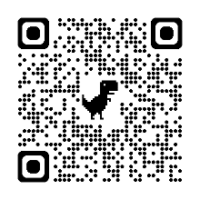  Snapshots https://tinyurl.com/KODUSsnapshots 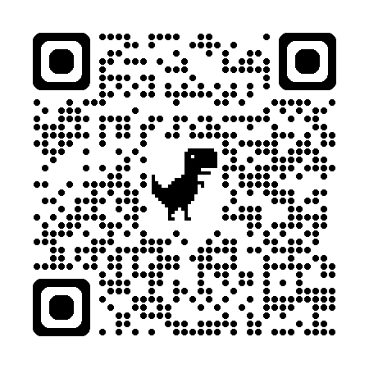

Prepared by:  JOHN MARK AGUSTIN E. ACIDO  Project Development Officer I |  | Reviewed by:  ALDIE MAE A. ANDOY  OIC, DRMD
Recommending Approval:

RAMIL M. TACULOD
Knowledge Management Team Chairperson
Approved by:

MARI-FLOR A. DOLLAGA-LIBANG
Regional Director

